You are the IT director at Big Ten University. As part of a training program, you decide to draw a DFD that includes some obvious mistakes to see whether your newly hired junior analysts can find them. You came up with the diagram 0 DFD shown in Figure 5-19. Based on the rules explained in this chapter, how many problems should the analysts find?

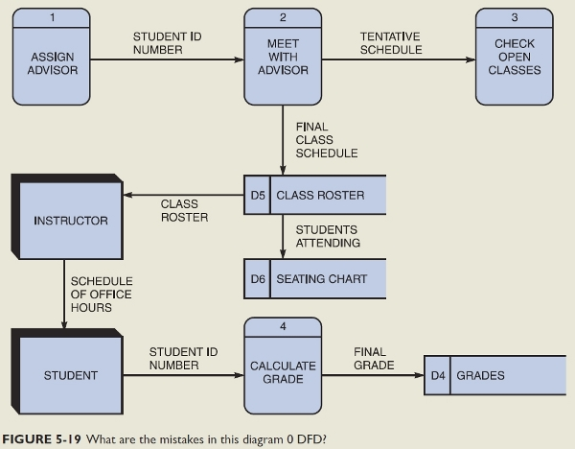

1. Process 1, **Assign advisor**, has no input.
2. Process 3, **Check open classes,** has no output.
3. Entity **Instructor** can not connect to entity **Student.**
4. Data store **Class roister** can not connect to **Seating chart**.
5. **Meet with advisor** should be **Meet advisor.**
6. **Check open classes** should be **Check classes.**
7. **Student id number** should be **Student id** x2**.**
8. **Schedule of office hours** should be **Office hours.**
9. **Final class schedule** should be **Class schedule.**